
Collaboration for Recovery, Resiliency and Empowerment
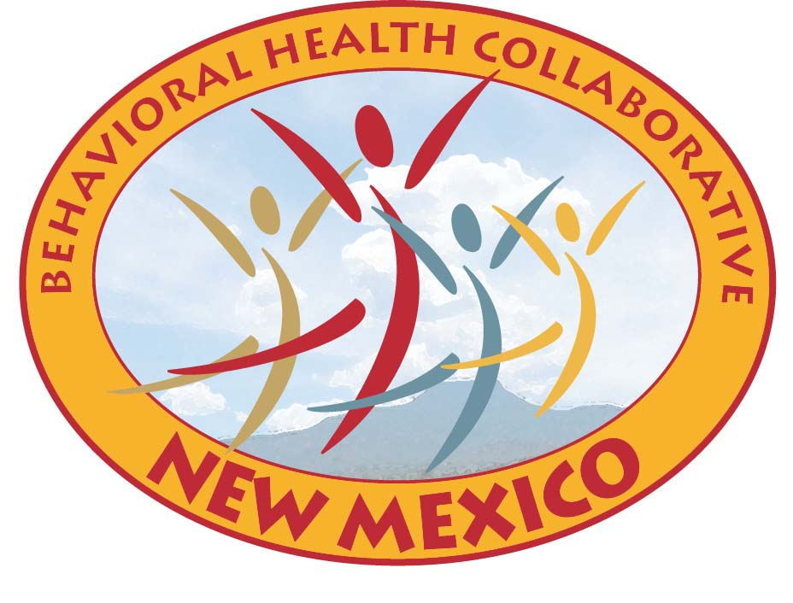

For Immediate Release July 13, 2011
Contact: Matt Kennicott (505) 827-6236 or (505) 819-1402

NM Behavioral Health Collaborative Meets Thursday,
July 14 in Santa Fe

Santa Fe, New Mexico – The New Mexico Behavioral Health Collaborative (Collaborative) will hold its next meeting on Thursday, July 14, 2011 from 1:30 to 4:00 p.m. at the Human Services Department office, located at 37 Plaza la Prensa in Santa Fe.

Video conferencing will also be available at the following locations:
- Albuquerque Child Support Enforcement Division (CSED) Office – 1015 Tijeras NW Suite 100 in Albuquerque
- Farmington CSED Office – 1800 E. 30th Street in Farmington
- Las Vegas CSED Office – 2536 Ridge Runner Rd. in Las Vegas
- Las Cruces CSED Office – 653 Utah Ave in Las Cruces
- Silver City CSED Office – 3088 32nd St. Bypass Rd., Suite B in Silver City
- Roswell CSED Office – 2732 North Wilshire Blvd in Roswell

Some of the items on the April agenda include:
- Behavioral Health Planning Council (BHPC) Report
- Directors Reports/Data
- Prevention Dollars
- Optum Health Status – Directed Corrective Action Plan (DCAP and Sanction)
- Quality Performance and Accountability
- Public Expert Panel Taskforce
- Public Input

The final agenda for Thursday’s meeting is posted on the Behavioral Health Collaborative website at http://www.bhc.state.nm.us/BHCollaborative/Agenda2010.html under the July 2011 tab.

About the Collaborative
The Collaborative was created during the 2004 Legislature to allow most state agencies and resources involved in behavioral health treatment and recovery to work as one in an effort to improve mental health and substance abuse services in New Mexico. This cabinet-level group represents 15 agencies and the Governor’s office.

###
Aging and Long-Term Services Department

Administrative Office
of the Courts

Children, Youth and
Families Department

New Mexico Corrections
Department

Department of Finance and Administration

Department of Health

Department of
Workforce Solutions

Department of
Transportation

Developmental
Disabilities Planning
Council

Division of Vocational
Rehabilitation

Governor’s Commission
on Disability

Governor’s Health
Policy Advisor

Health Policy
Commission

Human Services
Department

Indian Affairs
Department

Mortgage Finance
Authority

Public Education
Department

