
Collaboration for Recovery, Resiliency and Empowerment
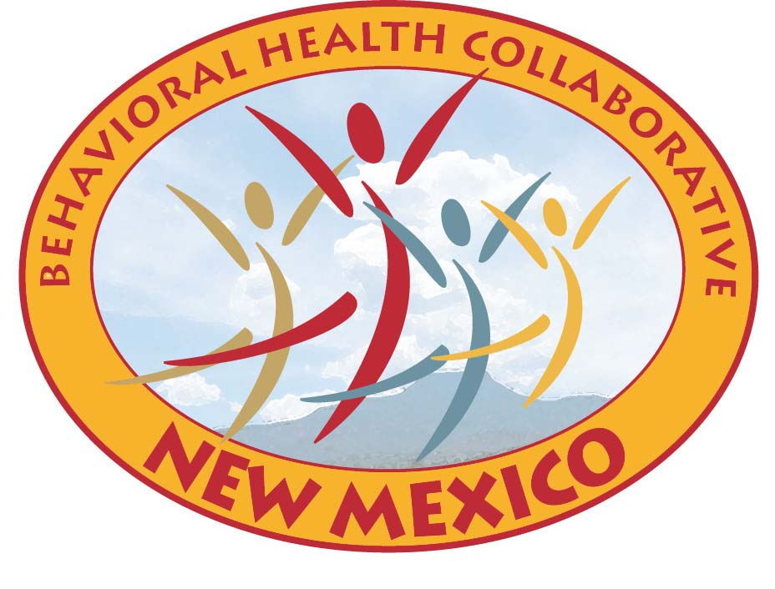
For Immediate Release: May 1, 2012
Media Contact: Matt Kennicott (505) 827-6236 or (505) 819-1402

Governor Susana Martinez Encourages New Mexicans to Celebrate Good Mental Health During the Month of May

May 9 is dedicated to Children’s Mental Health Awareness

SANTA FE – Governor Susana Martinez has proclaimed May 2012 as Mental Health Month and has dedicated May 9, 2012 as Children’s Mental Health Awareness Day in New Mexico.

“Mental health conditions are a challenge that we must help educate our communities about throughout New Mexico and the nation,” said Sidonie Squier, Human Services Department Secretary and co-chair of the NM Behavioral Health Collaborative. “Dedicating the month of May to increased awareness and education of mental health issues is an important step forward that must continue throughout the year.”

Special attention to children’s mental health will be held on May 9th, Children’s Mental Health Awareness Day. “Mental Health needs of children, youth and families are complex issues that require mindful policy and intervention strategies at every turn. For this reason it is important that at least one day a year is set aside to encourage our citizens, agencies and organizations to recognize this,” said Yolanda Deines, Children, Youth and Families Department Secretary and co-chair of the NM Behavioral Health Collaborative. “Our communities can each make a difference in a child’s life by recognizing the importance of acknowledging mental health needs as early in a child’s life as possible.”

“I look forward to offering a statewide educational webinar on community response to child trauma in recognition of this year’s Children's Mental Health Awareness Day. We understand that a child’s positive mental health is essential to their healthy development from birth. The Department of Health works collaboratively with other government agencies and community partners to ensure that New Mexicans have the proper education and materials to address the mental health of our youngest citizens,” said Dr. Catherine Torres, Department of Health Secretary.

In order to combat the epidemic of prescription opiod and heroin overdoses in youth in New Mexico, the state launched the “No Exceptions” campaign in February. “No Exceptions” is a comprehensive media campaign involving the New Mexico Behavioral Health Collaborative (BHC), the Human Services Department (HSD), the Public Education Department (PED), the Department of Health (DOH), the Heroin Awareness Committee (HAC), and private partners to help parents, educators, and middle and high school students throughout New Mexico understand the dangers of opioids and heroin. This video gives parents a tool they can use for their own education and also to help educate their children and helps teachers communicate to kids how to make the right decision when it comes to drug use. The campaign will utilize a variety of media to reach parents and youth with the information necessary to help keep kids safe. An ongoing media campaign is taking place throughout New Mexico, and in August a special will be aired on several television stations across the state in prime time with live in-person and web interaction.

The Governor’s proclamations (attached) encourage New Mexicans to celebrate Mental Health Month and Children’s Mental Health Awareness Day. Below are several events that are scheduled across the state.

May 1st from 12pm – 5pm Cibola County Mental Health Collaborative (LC 13) will be meeting at the Future Foundations Family Center and providing a presentation “Bringing Families Together: Models of Hope and Recovery”. Following the presentation they will host a Mental Health Fair (1-3pm). Snacks, games and prizes!

Aging and Long-Term Services Department

Administrative Office
of the Courts

Children, Youth and
Families Department

New Mexico Corrections
Department

Department of Finance and Administration

Department of Health

Department of
Workforce Solutions

Department of
Transportation

Developmental
Disabilities Planning
Council

Division of Vocational
Rehabilitation

Governor’s Commission
on Disability

Governor’s Health
Policy Advisor

Health Policy
Commission

Human Services
Department

Indian Affairs
Department

Mortgage Finance
Authority

Public Education
Department

Page 2…Mental Health Month

May 5th from 3pm-7pm Youth Jam will be held at Warehouse 508 in Albuquerque. Youth Jam is a community event planned by young people in Albuquerque with the support of adult allies and the sponsorship of many agencies and individuals. Youth Jam focuses on reducing suicide and substance use by linking young people and families to health and mental health services and supports in our community. In addition to a resource fair, Youth Jam celebrates youth talent, leadership, and strengths with a talent showcase, art projects, and fun activities for all community members. This year Youth Jam will honor people in the community who make a positive difference in the lives of young people and families with the very first Community Choice Awards.
Albuquerque City Council will be presenting a proclamation for Children’s Mental Health Awareness Day at their meeting on May 7, 2012. The Bernalillo County Commission presented their proclamation in support of Children’s Mental Health Awareness Day at their meeting April 10th.

May 5th beginning at 6pm ‘Youth Creating Change’ Film Festival & Art Gallery, featuring short films and public service announcement by middle and high school students, raising awareness on the issue of child and family homelessness in Albuquerque. Event will be hosted at the South Broadway Cultural Center in Albuquerque.

May 7th to 11th Mental Health First Aid Train-the-Trainer the University of New Mexico and OptumHealth New Mexico have partnered to train 30 people, representing diverse communities throughout NM to become Mental Health First Aid Trainers.

May 9th from 10am to 11:30am, NM Project LAUNCH (Linking Actions for Unmet Needs in Children’s Health) will be hosting a webinar on Adverse Childhood Experiences (ACE). The presenter will be Julianne Bodnar, MSW, LISW, speaking about child trauma and resiliency.
To register for this webinar, contact gloria.bonner@state.nm.us

May 9th Grant County Systems of Care will distribute coloring placemats to local schools and businesses. The placemats, which were developed by local youth, will be given to 1st and 5th grade classes and were created by local youth. Each of the placemats includes local resource information, tips on dealing with anger and artwork for youth to color.

May 12th local Grant County mental health providers, youth providers and systems of care team will sponsor a youth scavenger hunt in Silver City. Teams of youth between the ages of 13 and 18 will be given clues about a local providers which will lead them throughout the community. After all clues are gathered, they will gather at ‘The Youth Spot’, also known as The Wellness Coalition, to speak to the providers about the services they offer. Following the event the entire community is invited to a dinner and a youth concert.

May 14th from 5:30pm to 8:30pm the Systems of Care family group will be attending an event with former First Lady Rosalynn Carter “Within Our Reach: Ending the Mental Health Crisis” at UNM’s Popejoy Hall. Following the event family members are then invited to continue the discussion over pizza at Saggios. Please RSVP for this event by May 4th: lananmsoc@gmail.com

May 16th San Juan is hosting the San Juan Safe Communities Summit at the Farmington Civic Center from 8am to 5pm. A special evening presentation at 7pm will highlight early childhood and opioid addiction. The event is open to the community and CEU’s will be provided.
Page 2…Mental Health Month

May 19th NAMIWalk-New Mexico “Changing Minds...One Step at a Time for 2012”, a 5K Walk event designed to increase NAMI's visibility in the community and to raise awareness about mental illness and raise money for NAMI programs in New Mexico. NAMI stands for National Alliance on Mental Illness. The 5K begins at 9am from Albuquerque Academy.

May 21st through 25th Santa Clara Pueblo Systems of Care will provide the Santa Clara Day School students (grades K-6th) with Mental Health Awareness educational activities including art projects and puppet shows. In addition to these activities each week in the month of May a mental health awareness article will be published in their local newsletter.

May 26th Local Behavioral Health Collaborative 6 will be sponsoring an informational booth at the Silver City Blues Festival from 10am-2pm at Gough Park in Silver City. The booth will be staffed by consumers from the Border Area Mental Health New Beginnings Psychosocial Recovery Program. They will be distributing information on behavioral health, inclusion, and local services. The Silver City Blues Festival is a free annual event that draws an estimated 10,000 persons from around the region over the Memorial Day Weekend.

May 31st from 10am to 4pm Valencia Counseling Services Inc. and OptumHealth New Mexico are sponsoring Mental Health Awareness Fair at the Los Lunas Walmart. The Optum Hope Mobile will be on site to provide free health screenings. Join them to learn about mental illness, treatment, hope and recovery. There will be food, drinks, resources and prizes!

Page 3…Mental Health Month

June 15th from 10am to 2pm Local Behavioral Health Collaborative 11 will be hosting an a mental health information, education and awareness event with games, booths, speakers and a picnic at Ford Canyon City Park.

June 16th from 11am to 2pm the 4th Annual Mental Health Awareness Picnic, hosted by Local Behavioral Health Collaborative 8, will be hosted at Cimarron Park. This informative gathering of community members will be a time for food, fun, and fellowship and will assist in the reduction of stigma and misunderstanding related to people receiving behavioral health services. A bus will be leaving Tri-County Community Services in Taos at 9:00 in the morning to attend the picnic. There are 50 seats available and all families are welcome!

About the Collaborative
The Collaborative was created during the 2004 Legislature to allow most state agencies and resources involved in behavioral health treatment and recovery to work as one in an effort to improve mental health and substance abuse services in New Mexico. This cabinet-level group represents 15 agencies and the Governor’s office.

###

