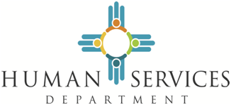
Community Services Block Grant

Fact Sheet
The Community Services Block Grant (CSBG) is a formula grant from the U.S. Department of Health and Human Services (HHS). CSBG provides a flexible funding source to HSD for the reduction of poverty in local communities through a network of Community Action Agencies (CAAs). The six-agency network covers the entire state. Within HSD, CSBG is administered by the Income Support Division/Work and Family Support Bureau.
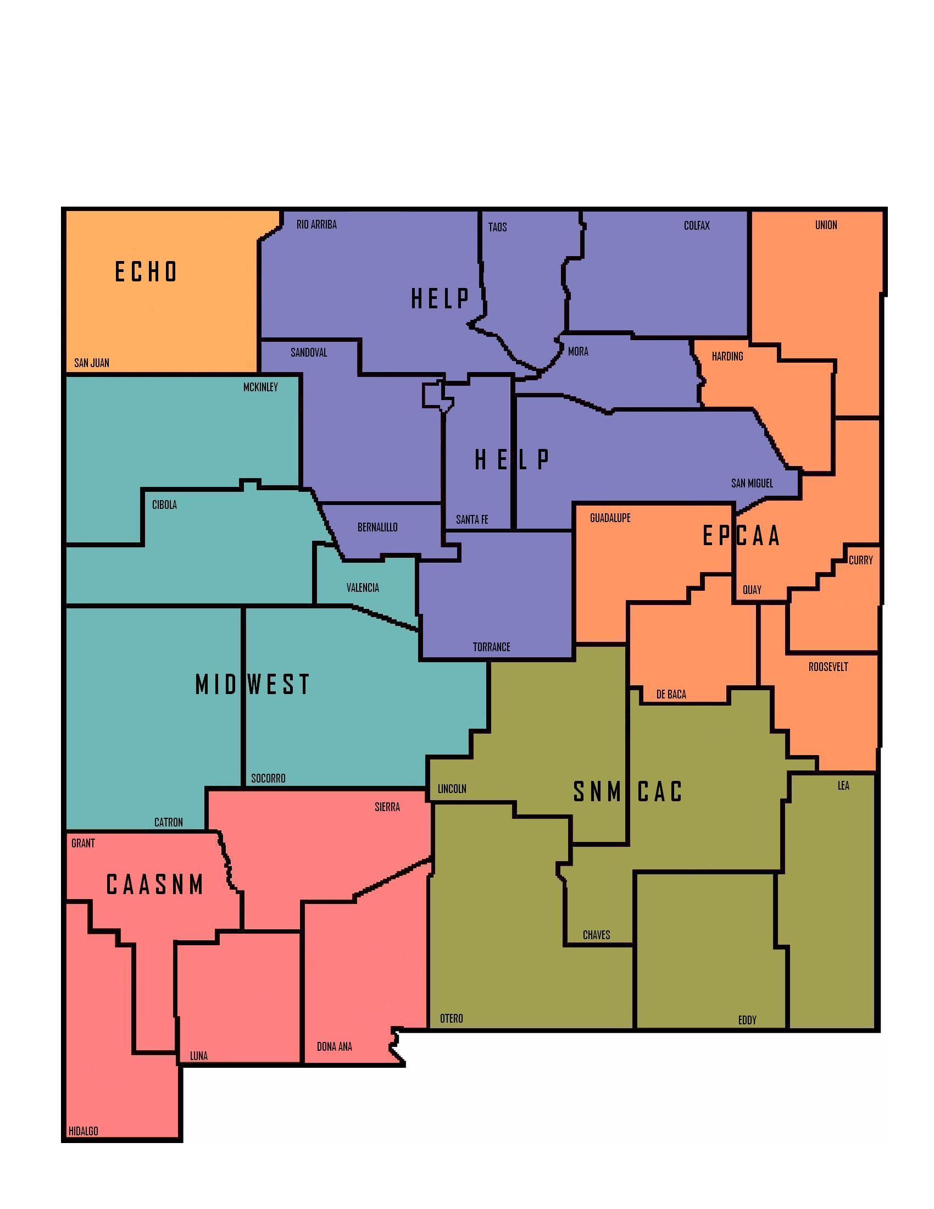
- Funding

- Federal Funding
  - 2014--pending
- 2013--$3,467,113
- 2012--$3,696,732
- 2011--$3,853,550
- 2010--$3,963,326

- Allocation of Funds set by Federal Statute
- 90% to Eligible Entities (CAAs).
- 5% for HSD Administrative Expenses.
- 5% for Discretionary Spending.

- HSD awards four-year Sole Source Professional Service Contracts (amended Service Contracts (amended annually)
  - A base allocation of $50,000 to each CAA for regular CSBG funding.
  - $79,516 to HELP NM for statewide seasonal and migrant farm workers services.
  - Remainder apportioned to CAAs by county poverty census data.

- Eligible Entities
- CAAs can be designated as of September 30, 1981 under the provisions of the federal Economic Opportunity Act of 1964, or by the Governor under the New Mexico Community Action Act of 1983.
- All CAAs currently operating in New Mexico are designated under the federal provisions.

Community Action Agencies (CAAs) | SFY 2014 Funding
Community Action Agency of Southern NM (CAASNM) | $549,897
Eastern Plains Community Action Agency (EPCAA) | $170,513
Economic Council Helping Others, Inc. (ECHO) | $216,424
HELP New Mexico—10 Counties | $1,273,022
HELP New Mexico – Migrant | $ 79,516
Mid-West Community Action Program (MIDWEST) | $369,960
Southeastern NM Community Action Corp (SNMCAC) | $407,754
- Program Elements

- Services

- Examples of CAA Services:
- Employment – On the Job Training, work experience, job placement, counseling, self-employment
- Education – Head Start, before and after school programs, vocational training, post-secondary, GED, pre-employment certification training, literacy, school supplies
- Emergency Services – Rental/mortgage assistance, utility assistance, emergency medical assistance, food vouchers and/or boxes, information and referral
- Nutrition – Food Bank, food pantries, food boxes, children and senior meals, summer food program, child back-pack program, delivery of food to home-bound seniors and disabled individuals
- Income Management – Free tax preparation services, Individual Development Accounts (IDA), financial counseling and financial literacy classes
- Housing – Rehabilitation and weatherization, administrative expenses related to the construction of new homes, home buyers education classes
- Health Initiatives – Prescription assistance, Adult Day Services, Covering Kids program, and Head Start—children immunization, medical and dental check-ups information and referral
- Build Partnerships – To expand resources and opportunities for low-income individuals and families
- Promote Self-Sufficiency – Financial counseling and budgeting, childcare services, employment and training services, parenting classes

- FFY 2012 Program Outcome Excerpts
- Funds Leveraged - $47,589,618 of federal, state, local and private funding using CSBG funding
- Families Served –
  - Total unduplicated number of families about whom one or more demographic characteristics were obtained: 17,924
  - Total unduplicated number of families about whom no demographic characteristics were obtained: 33,986
- 5 CAAs provided employment assistance
  - 409 unemployed participants obtained a job
  - 3,888 obtained skills/competencies required for employment
- 4 CAAs offered free tax preparation assistance
- 6,917 participants were served
- 3,945 participants qualified for tax credits
    - $2,644,475 in federal and state tax credits realized
  - 3 CAAs offered asset development services
    - 22 individuals started small businesses through accumulated savings
    - 19 individuals pursued post-secondary education through accumulated savings
    - 12 families purchased homes through accumulated savings
- 3 CAAs offered home weatherization/rehabilitation services
  - 464 homes were improved
- 6 CAAs offered assistance to vulnerable individuals to help them maintain an independent living situation
  - 19,849 seniors served
  - 5,592 disabled individuals served
- 4 CAAs provided emergency food assistance
    - 38,649 individuals received emergency food
- 6 CAAs reported
    - 6,303 individuals received emergency utility assistance
- 6 CAAs reported
    - 13,719 children received adequate nutrition to improve health and physical development
    - 4,096 children enrolled in pre-school activities to develop school readiness skills
  - 5 CAAs distributed
    - 650,614 food boxes
    - 6,138,803 pounds of food

- Current Events

- CSBG Funding and Performance Management
- NM’s final FFY14 funding level is unknown. A Continuing Resolution (CR) is in effect through January 15, 2014. NM’s allotment for the period covered by the CR is $1,027,375.
- FFY 13 Program Outcomes will be available in April 2014.
- The HHS Office of Community Services (OCS) has received proposed organizational standards for CAAs and proposed performance measures for CSBG State Offices. OCS plans to provide guidance on implementing the CAA standards and State Office performance measures.

- Contact information:

Bill Wuestenhagen, Management Analyst
CSBG State Office
Work and Family Support Bureau
NM HSD/Income Support Division
2009 S Pacheco St (87505)
PO Box 2348
Santa Fe, NM 87504-2348
WilliamG.Wuestenhag@state.nm.us
Office: (505) 827-7251
Fax: (505) 827-7259
Wk Cell: (505) 401-1185

